燈迎福祿 | 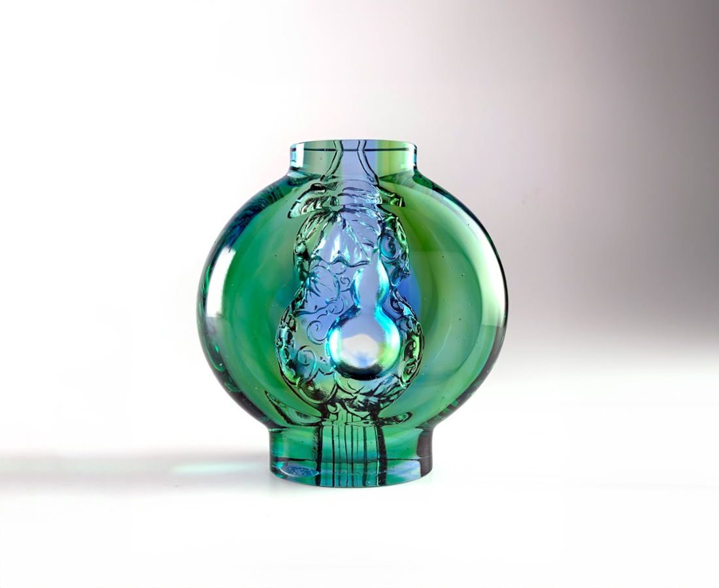
圓融 靈活自如
珍惜 綿延不絕
福祿滿門
點亮幸福圓滿的祝福
Fortune Lantern
A gourd is a symbol of happiness and longevity in chinese culture. Its smooth and round shape also means harmony and flexibility. Based on the design concept, the combination of the lantern and gourd represents both light and happiness. This art piece has a gentle luster which signifies grand success and future happiness.

編號 | 1103356 | No | 1103356
名稱 | 燈迎福祿 | Name | Fortune Lantern
顏色 | 藍綠透 | Color | blue,green,clear
尺寸 | 9.9 * 4.3 * 10.4 | Size | 9.9 * 4.3 * 10.4
重量 | 0.62 | Weight | 0.62
限量 | X | Limited Edition | X
售價 | NT$ 4680 | Price | NT$ 4680
 | RMB$ 1050 |  | RMB$ 1050

