馬上有錢 | 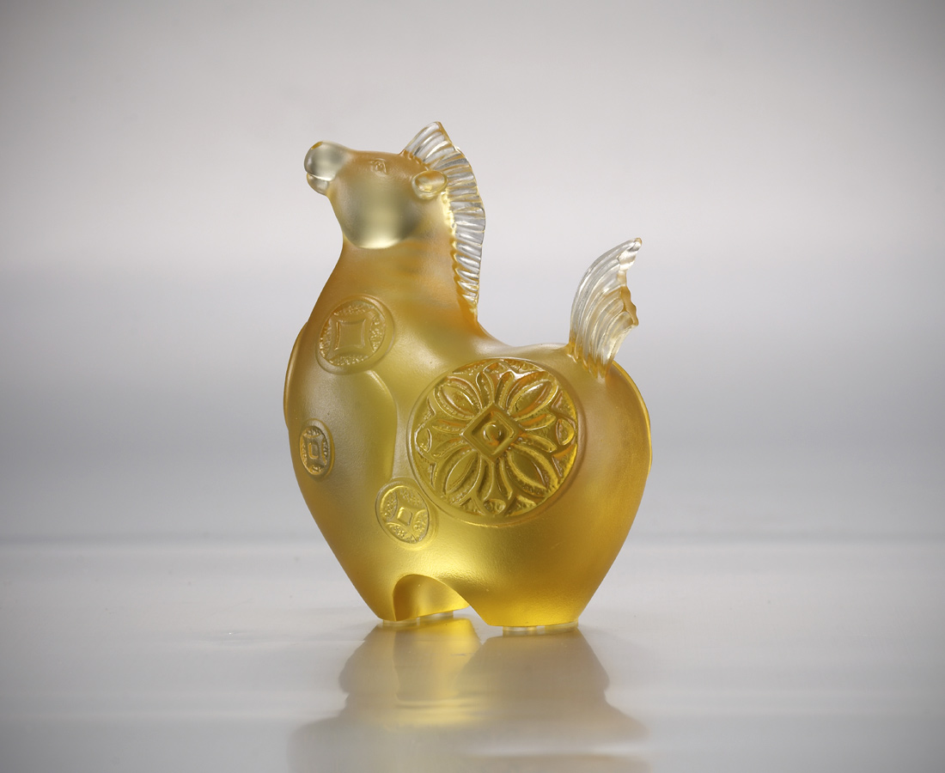
抖擻精神
笑臉迎人
一身富貴
馬上而來
Immediate Wealth
Coin images are engraved onto this adorable horse, symbolizing that an open-minded attitude heralds the coming of happiness and good luck in daily life.

編號 | 1103331 | No | 1103331
名稱 | 馬上有錢 | Name | Immediate Wealth
顏色 | 金 | Color | golden
尺寸 | 7.8 * 5 * 9.7 | Size | 7.8 * 5 * 9.7
重量 | 0.5 | Weight | 0.5
限量 | X | Limited Edition | X
售價 | NT$ 3980 | Price | NT$ 3980
 | RMB$ 880 |  | RMB$ 880

