掌上明珠 | 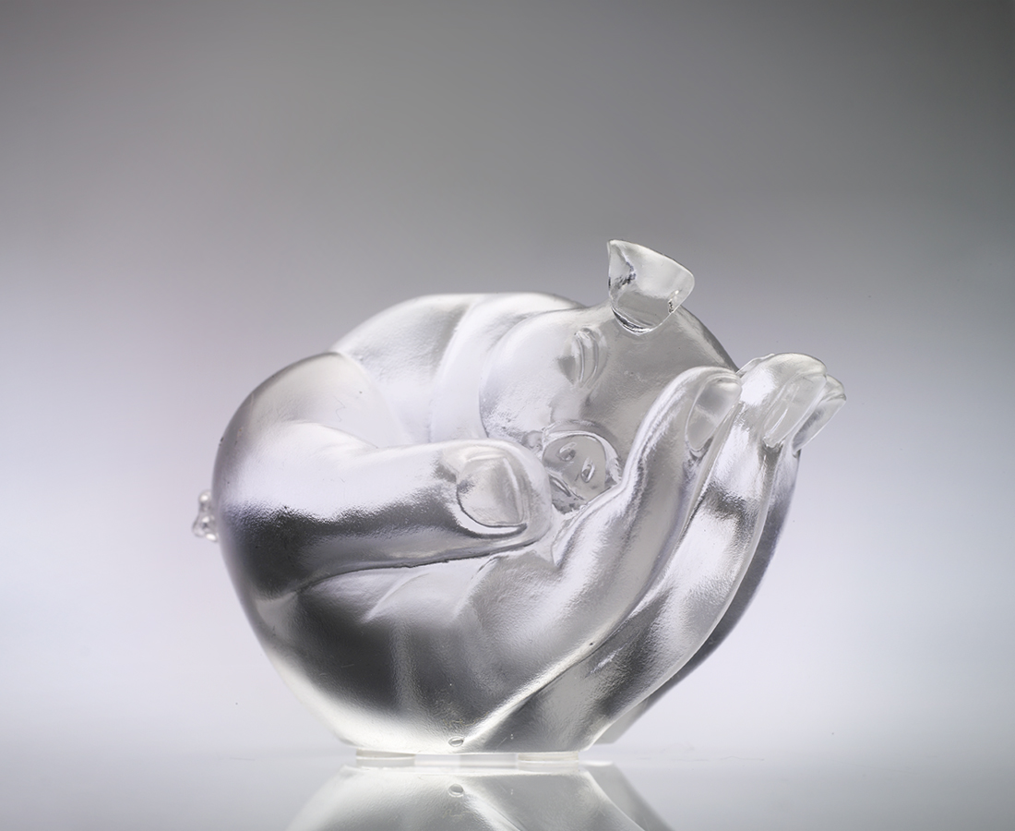
不想忙進忙出
萬事萬物 泰然處之
不再人前人後
無時無刻 怡然自得
用心生活 寵愛自己
當下幸福滿足而歡喜沉浸
人見人愛
A Jewel in Hand
Busy life has come to an end Let everything be as is Only focus on own feelings At all time, and at ease Live the life with true heart Feel the happiness and blessings And overwhelmed by joy

編號 | 1102489 | No | 1102489
名稱 | 掌上明珠 | Name | A Jewel in Hand
顏色 | 透 / 金 | Color | clear / golden
尺寸 | 5.6 * 8.3 * 6.3 | Size | 5.6 * 8.3 * 6.3
重量 | 0.35 | Weight | 0.35
限量 | X | Limited Edition | X
售價 | NT$ 3680 | Price | NT$ 3680
 | RMB$ 922 |  | RMB$ 922

