諸事平安 | 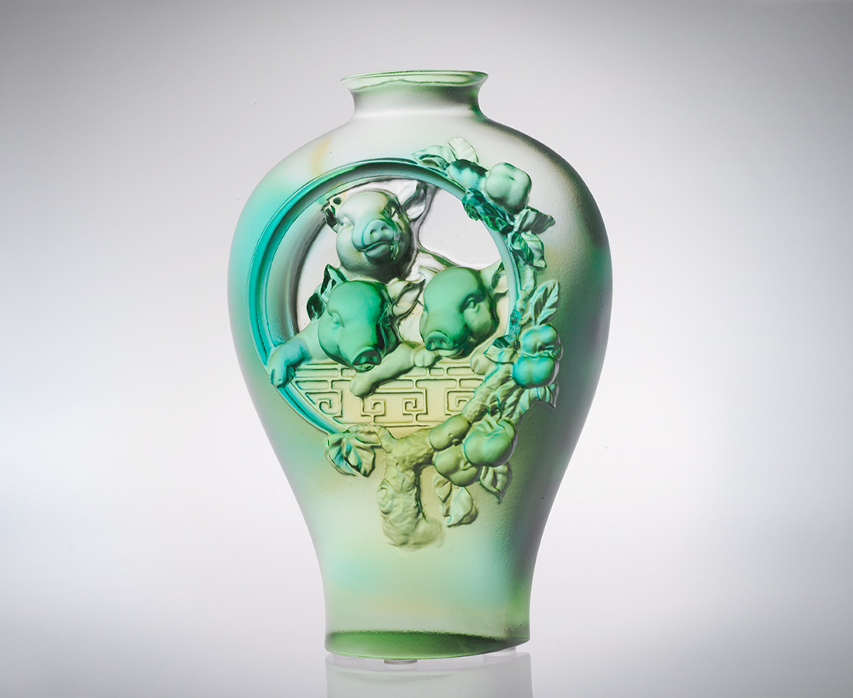
有緣 共享樂
有心 共患難
一起行動 信心強
一起打拼 力量大
福份加持 豐收加倍
諸事平安都如意
All is Safe and Sound
Affinity bring us union Through good times or bad We cherish our friendships Togetherness enhances confidence Togetherness offers us strength Working in harmony The reward reaped, Is greater than ever before With good fortune and luck All will be safe and sound

編號 | 1102464 | No | 1102464
名稱 | 諸事平安 | Name | All is Safe and Sound
顏色 | 粉琥綠透 | Color | gpink, amber, green, clear
尺寸 | 4 * 8.7 * 12.5 | Size | 4 * 8.7 * 12.5
重量 | 0.53 | Weight | 0.53
限量 | X | Limited Edition | X
售價 | NT$ 4380 | Price | NT$ 4380
 | RMB$ 1088 |  | RMB$ 1088

