歡喜自足 | 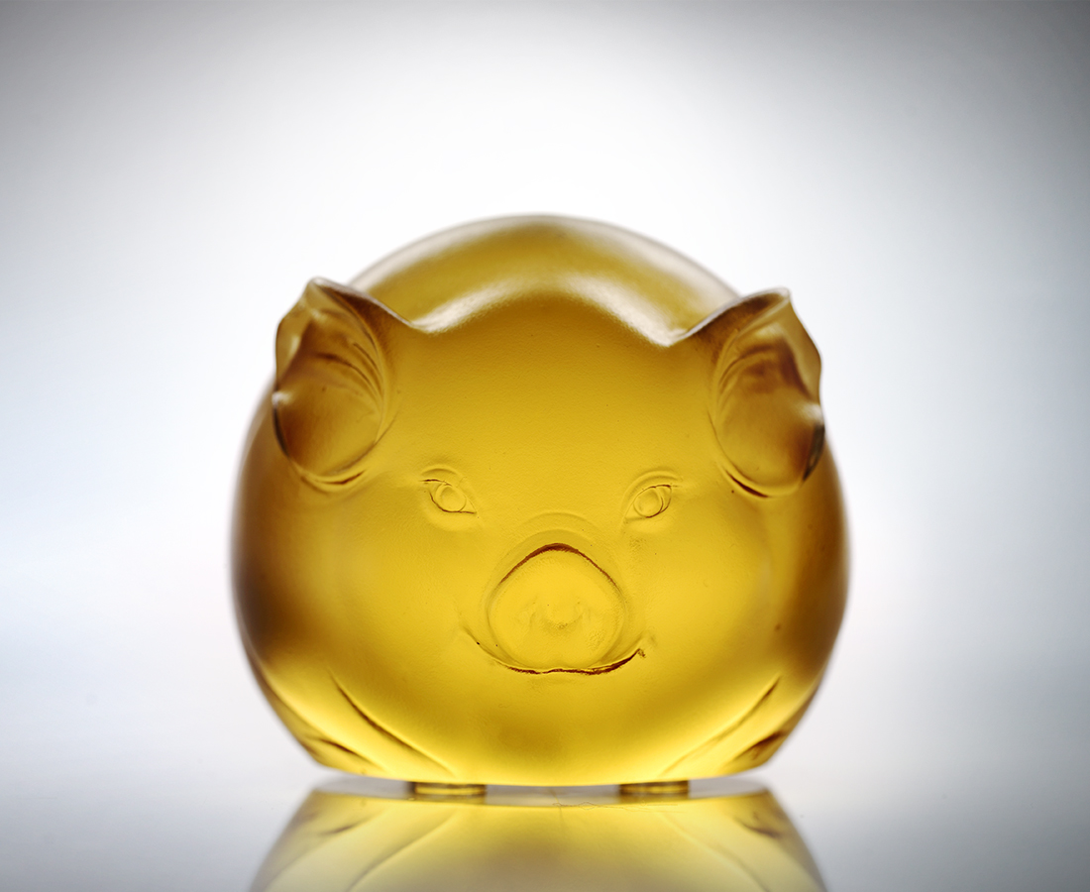
不傷人 心要寬
不傷己 人要圓
常常和顏悅色
默默行事積善
人緣看漲 事業看好
生活濃情厚味
生命歡喜富足
Self Satisfaction
Keep an open mind and hurt no others And you will be paid in kind Stay that smile on your face Do kindness onto others And everything will be better Live with feelings and passions And enjoy life with its endless riches

編號 | 1102421 | No | 1102421
名稱 | 歡喜自足 | Name | Self Satisfaction
顏色 | 金 | Color | golden
尺寸 | 7 * 6.2 * 5.3 | Size | 7 * 6.2 * 5.3
重量 | 0.49 | Weight | 0.49
限量 | X | Limited Edition | X
售價 | NT$ 3280 | Price | NT$ 3280
 | RMB$ 822 |  | RMB$ 822

