樂聲 | 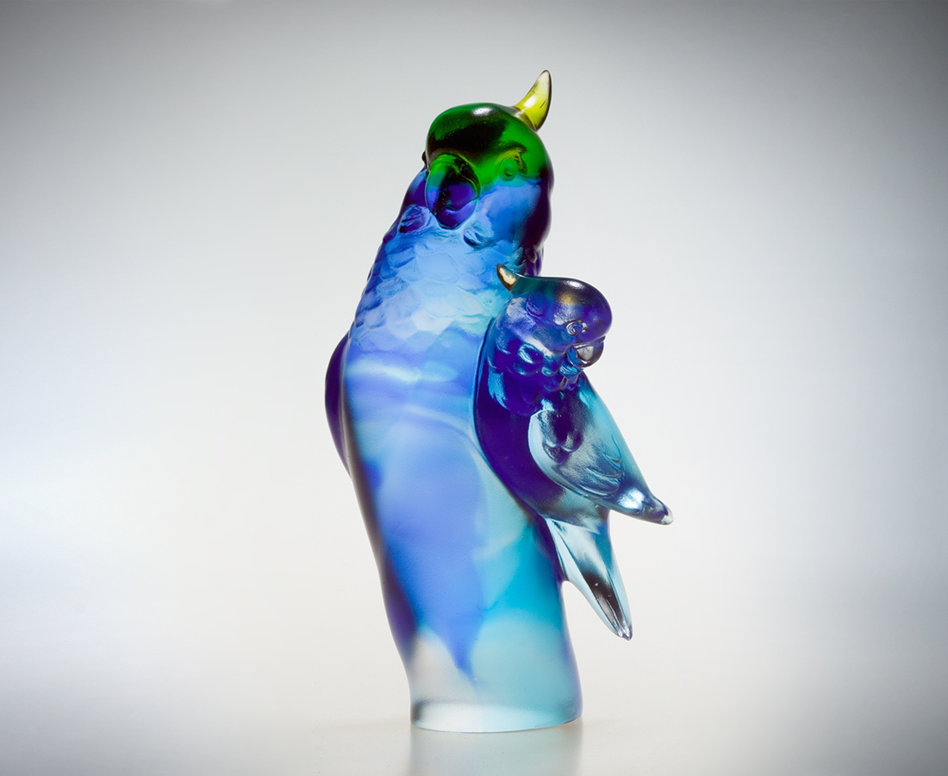
不必歌聲
澎湃依然
不必舞動
熱情依舊
你我情真
悠然流轉
美麗視野
豁然開朗
Sounds of Happiness
In the absence of music and song The emotion overflows Without form or movement The passion remains With true love Between us The future looks beautiful and bright Overflowing with joy and hope

編號 | 1102255 | No | 1102255
名稱 | 樂聲 | Name | Sounds of Happiness
顏色 | 藍透綠 | Color | green, blue, clear
尺寸 | 8*7.6*16.2 | Size | 8*7.6*16.2
重量 | 0.93 | Weight | 0.93
限量 | X | Limited Edition | X
售價 | NT$ 6280 | Price | NT$ 6280
 | RMB$ 1566 |  | RMB$ 1566

