圓滿高陞 | 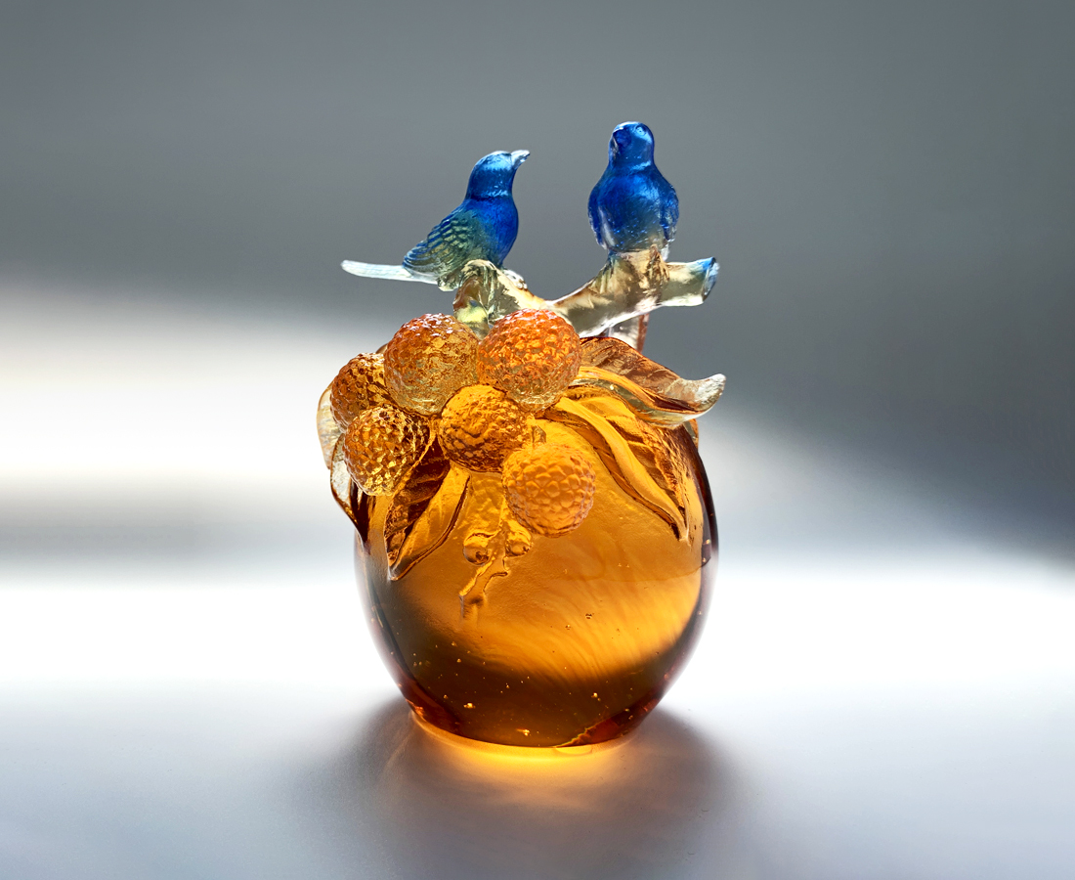
圓熟的香甜內涵
圓實的親切質感
圓潤的舒暢心胸
以耐心關懷灌溉
以惜福感恩滋養
春耕夏耘 豐收結果
學習圓的簡單形式
而因緣圓轉連連高陞
Rings of Fulfillment
The round fruit ripens with plumpness. The round sphere curves with smoothness. The round circle embraces with openness. Nurture with patient care Nourish with grateful kindness, The seasonal harvest from routine works Teaches us the simple mode of circularity, Where ringed circle spirals to soar infinitely high.

編號 | 1102252 | No | 1102252
名稱 | 圓滿高陞 | Name | Rings of Fulfillment
顏色 | 琥金藍 | Color | amber, golden, blue
尺寸 | 9.4 * 8.5 * 12 | Size | 9.4 * 8.5 * 12
重量 | 1.07 | Weight | 1.07
限量 | X | Limited Edition | X
售價 | NT$ 5900 | Price | NT$ 5900
 | RMB$ 1450 |  | RMB$ 1450

