如意至寶 | 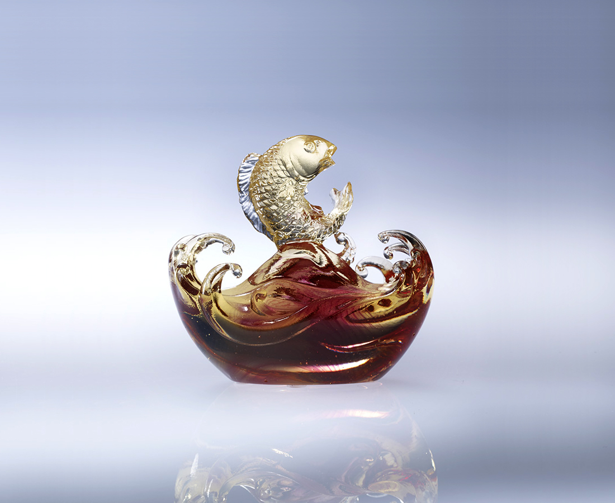
智慧 懂得形勢 順利上進
氣魄 精益求精 勢如破竹
度量 結交四方 風調雨順
眼光 信心包容 人生至寶
看到機會 毅力堅定更上樓
而如魚得水 悠游自在
而如意餘裕 隨心所欲

Wish Granted
Wisdom – the field knowledge that allows successful advancement. Courage – the insistence that breaks through obstacles to perfection. Forgiveness – the bond that secures friendship all around for peace. Discernment – the confidence that accommodates the vastness of life. Reinforce the perseverance by locking the goal in sight, So you swim toward success with fish-like ease And prosperity comes to you at will.

編號 | 1102235 | No | 1102235
名稱 | 如意至寶 | Name | Wish Granted
顏色 | 金紅透 | Color | gold, red, clear
尺寸 | 9 * 5.1 * 8.9 | Size | 9 * 5.1 * 8.9
重量 | 0.4 | Weight | 0.4
限量 | X | Limited Edition | X
售價 | NT$ 4280 | Price | NT$ 4280
 | RMB$ 1080 |  | RMB$ 1080

