堂皇龍鎮 | 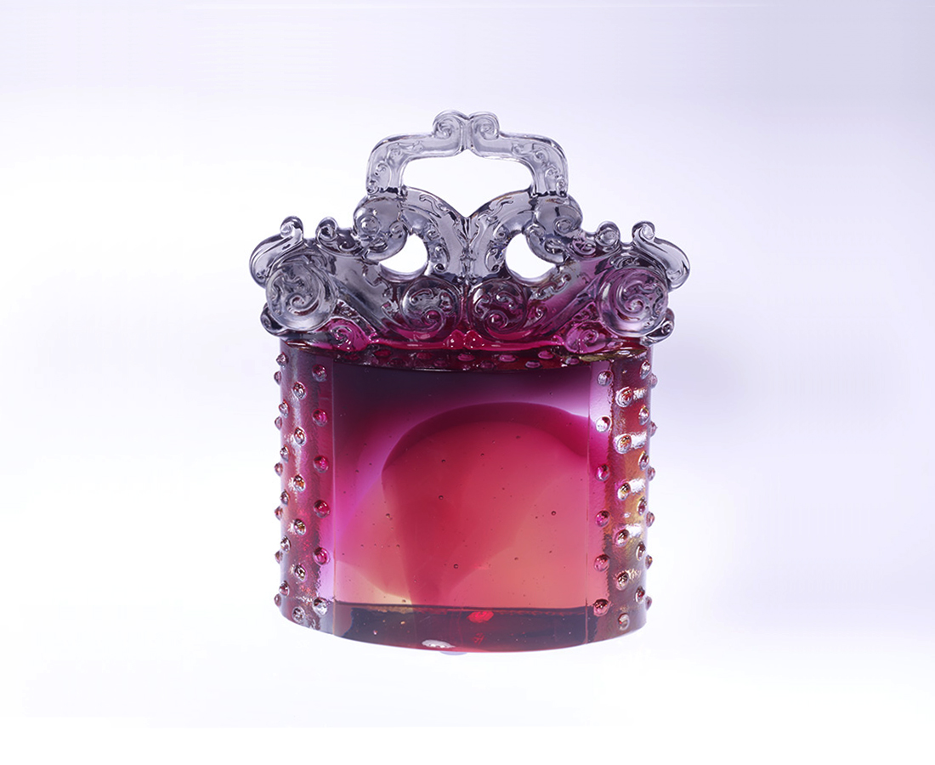
回首來時路
踏實堅忍 刻苦銘心
遠眺新目標
挑戰巔峰 戰戰兢兢
向從前 虛心學習
向未來 積極開創
讓智能日月厚實而自信鼎盛
讓殿堂冉冉上昇而莊嚴堂皇
Stately Dragon Paperweight
Let’s look back to the previous road visited here. It is sustainable to preserve the unforgettable memoir. Take a distant outlook over these brand new targets, Challenge the peak being meticulous in dealing events. To modestly take advice from the former experience To aggressively create performance by future chance Let intelligence and confidence increase immediately. Let the hall rises high gradually and the majesty is stately.

編號 | 1102053 | No | 1102053
名稱 | 堂皇龍鎮 | Name | Stately Dragon Paperweight
顏色 | 金紅灰透 | Color | gold, red, gray, clear
尺寸 | 4.3 * 8.7 * 10.3 | Size | 4.3 * 8.7 * 10.3
重量 | 0.6 | Weight | 0.6
限量 | X | Limited Edition | X
售價 | NT$ 5580 | Price | NT$ 5580
 | RMB$ 1388 |  | RMB$ 1388

