乘雲如意鎮 | 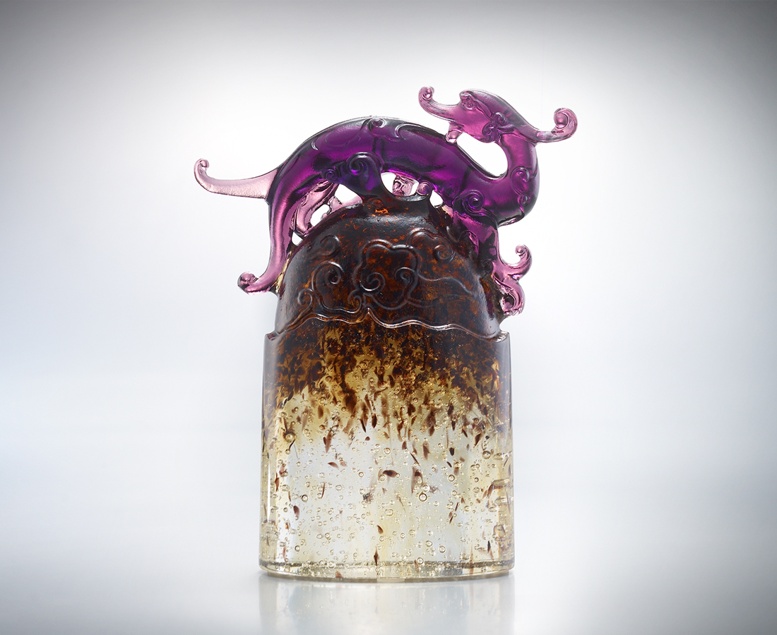
識實務 事半功倍
順時勢 一日千里
眼光深遠 如龍
先知先覺而氣象萬千
行動果斷 如風
一馬當先而勢如破竹
借力使力 乘雲如意
主動積極 登峰造極
Stepping Cloud Peaceful Paperweight
If you understand practical affairs more deeply Then yield double results with half effort actually. If you follow the current then you will advance beyond. If your insight is similar to being the Dragon profound, As a prophet has spectacular insight and elegant spirit His decision is as resolute as the overwhelmingly blast. Take the leading action and crush down enemy’s resistance Hand down and employ the power to step soaring cloud peace Thus you will aggressively reach and ascend the wonderful peak

編號 | 1102051 | No | 1102051
名稱 | 乘雲如意鎮 | Name | Stepping Cloud Peaceful Paperweight
顏色 | 灰透／金綠透 / 紫琥黑透 | Color | gray, clear／gold, green, clear
尺寸 | 3.8 * 9.1 * 11.2 | Size | 3.8 * 9.1 * 11.2
重量 | 0.53 | Weight | 0.53
限量 | X | Limited Edition | X
售價 | NT$ 5560 | Price | NT$ 5560
 | RMB$ 1388 |  | RMB$ 1388

