暖洋洋 | 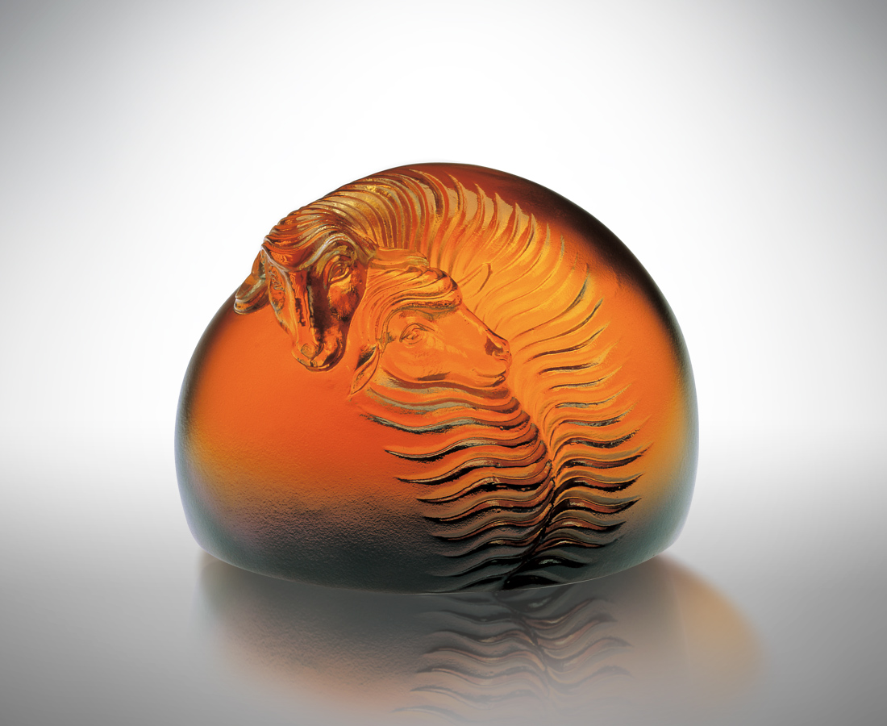
擠一擠
擠進心心相印的溫柔
擁抱軟綿綿的寬容
靠一靠
靠近無微不至的關懷
沉醉暖洋洋的濃情
做相知相惜的好角色
外圓內實 一團和樂
溫馨滿懷 安然自在
Warmth
Squeeze a bit, There will be heart to heart tenderness squeezed in, With soft leniency embraced. Approach a bit, There will be meticulous concern, Immersed in the warm affection. Be nice roles of mutual understanding and care. Peace and joy are felt both inside and outside. Full tenderness goes along with ease and comfort.

編號 | 1101017 | No | 1101017
名稱 | 暖洋洋 | Name | Warmth
顏色 | 紫琥透 | Color | amber, purple, clear
尺寸 | 5.5 * 6.5 * 5 | Size | 5.5 * 6.5 * 5
重量 | 0.27 | Weight | 0.27
限量 | X | Limited Edition | X
售價 | NT$ 2980 | Price | NT$ 2980
 | RMB$ 688 |  | RMB$ 688

