共榮一世 | 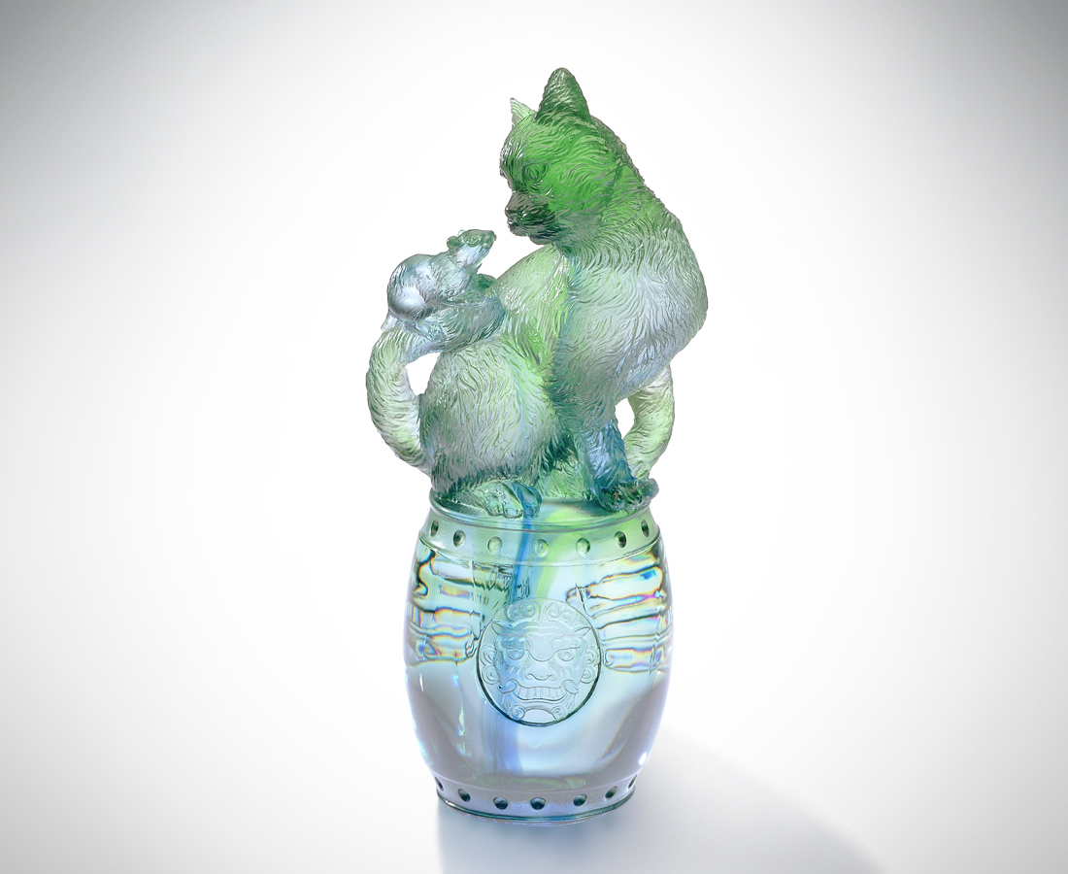
一個萬歲的新故事
停 是傾聽的信號
每一秒牽動了善意
沒有千鈞一髮的時差
只有設身處地的尊重
交情是真誠的議題
非關歷史 非關傳統
互信是平等的問題
不分大小 不計前嫌
歡歡喜喜 共榮一世
Enjoying Prosperity Together Forever
It’s a new story on longevity. Standing still is the signal of listening. Every second triggers off kindness. There is no time-difference of imminent peril, But the respect of thoughtfulness. Friendship is the topic of sincerity: It is irrelevant to history and tradition. Mutual trust is a matter of equality. Age difference and previous errors are nothing. Enjoying prosperity cheerfully forever.

編號 | 1101012 | No | 1101012
名稱 | 共榮一世 | Name | Enjoying Prosperity Together Forever
顏色 | 藍綠透 | Color | blue, green, clear
尺寸 | 5.9 * 4.2 * 12.8 | Size | 5.9 * 4.2 * 12.8
重量 | 0.43 | Weight | 0.43
限量 | X | Limited Edition | X
售價 | NT$ 5260 | Price | NT$ 5260
 | RMB$ 1322 |  | RMB$ 1322

